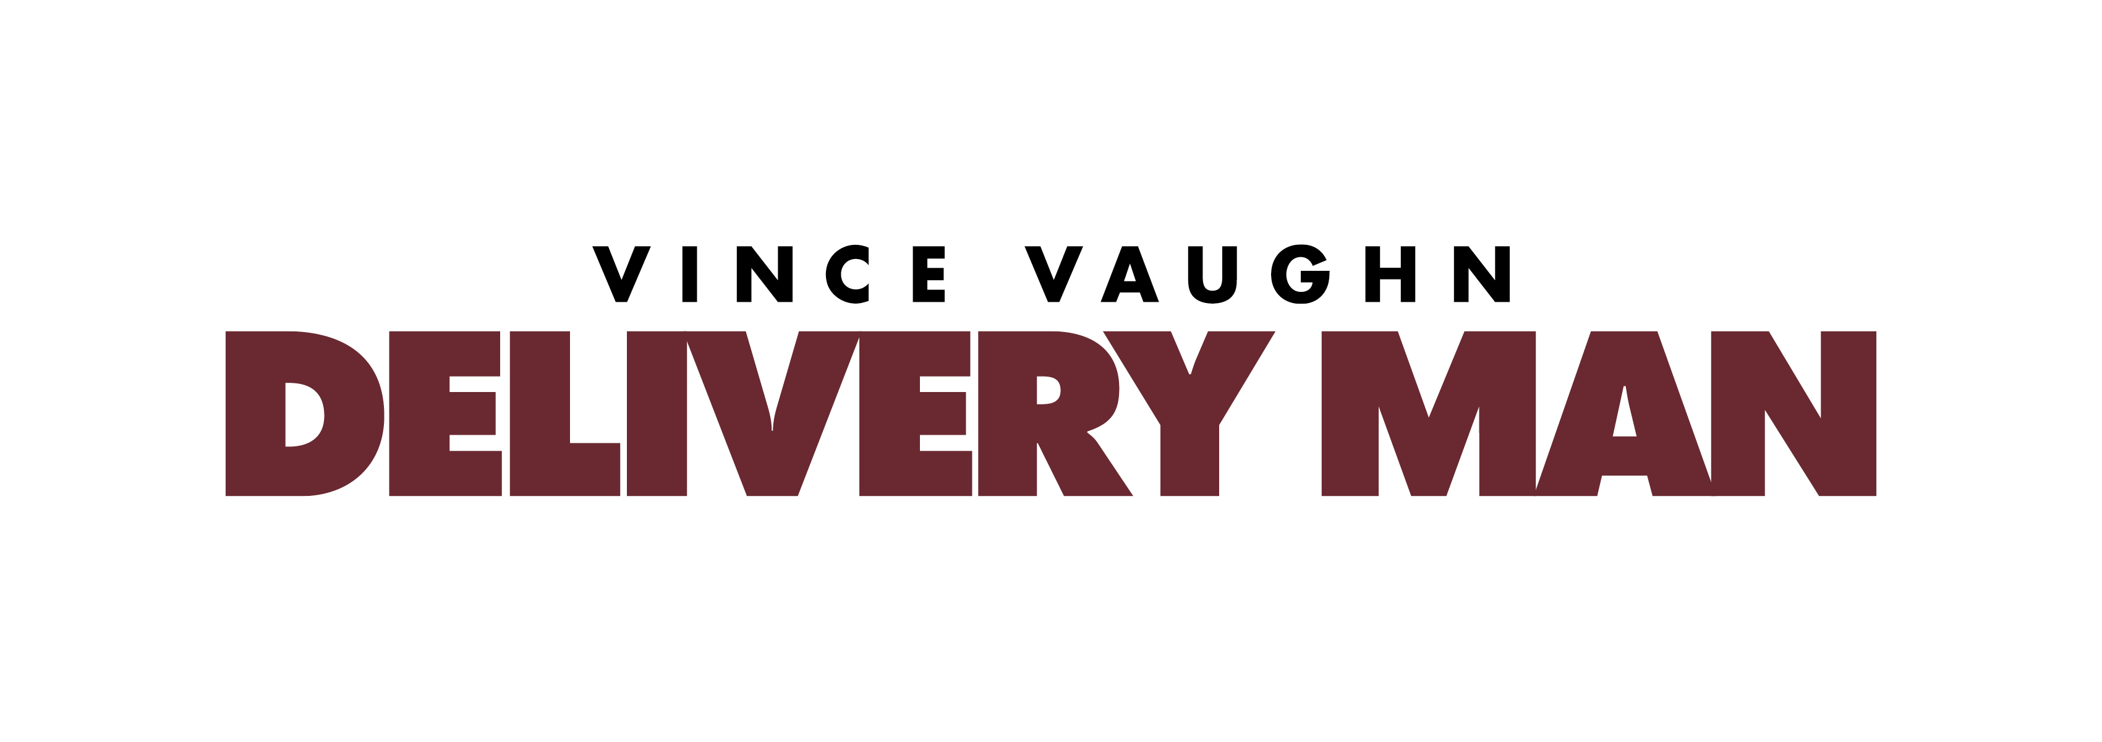

POZDRAVY ZE SPERMABANKY
DELIVERY MAN
Production Information

D
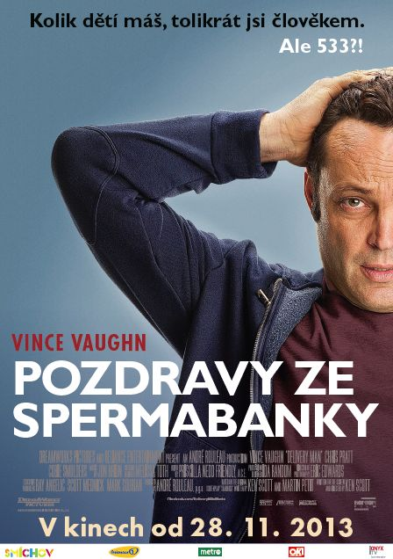
avid Wozniak (Vince Vaughn) has always led a simple life. A delivery driver for his family’s meat company, he is seemingly content existing in a state of perpetual mediocrity. While David has a good heart, charming everyone he comes in contact with, he is immature, unfocused, in serious debt and in desperate need of some sense of direction in his life. But when he finds out he is the biological father of 533 children and 142 of them are suing to learn his identity, everything changes, and David decides he wants to do the right thing and for once, be held accountable for his actions.
Eager to learn more about some of his newly found progeny, he tracks them down and begins looking out for them. Rather unexpectedly he becomes involved with these kids emotionally, and for the first time in his life understands how good it feels to put the interests of others ahead of his own. David wants to see them excel in life, and like a covert guardian angel he offers advice when warranted, encouragement when needed or a shoulder to cry on when sought, and begins to grasp all the precious things in life he has been missing. At the same time, David’s girlfriend, Emma (Cobie Smulders), enlightens him with news of her pregnancy, but knowing David, her expectations are minimal. David’s recent trials and tribulations, however, have helped him grow in ways he never imagined possible, and he finally understands he has been given a purpose in life, and this time he won’t let anyone down, least of all, his children.
DreamWorks Pictures and Reliance Entertainment present, “Delivery Man,” a heartfelt comedy about the complexities of life, seizing the day and becoming the person you are destined to be. The film stars Vince Vaughn, Chris Pratt and Cobie Smulders, and is written for the screen and directed by Ken Scott. “Delivery Man” is produced by André Rouleau, with Ray Angelic, Scott Mednick and Mark Sourian serving as executive producers. Eric Alan Edwards is the director of photography, Ida Random is the production designer, Priscilla Nedd-Friendly is the editor, Glenn Allen and Richard Friedlander are the VFX producers, and Eran Dinur is the VFX supervisor. Melissa Toth is the costume designer and the music is by Jon Brion.
A DreamWorks Pictures and Reliance Entertainment presentation, “Delivery Man” is based on the original screenplay “Starbuck,” written by Ken Scott and Martin Petit.

Casting Vince Vaughn in a New Light
Vince Vaughn has starred in some of the biggest box office comedies of the past decade, winning over audiences with his characteristic deadpan delivery and scathing sense of humor. Having played the lovable Everyman many times before, “Delivery Man” serves as a departure for him as an actor. A touching story filled with honesty and hope – in addition to humor – the film gives audiences a glimpse of a more mature Vince Vaughn.
Now married and the father to two children of his own, Vaughn was drawn to the role of David Wozniak as he wanted to address the issues of balancing life and family from a fresh perspective.
“It’s a great premise that is a little bit crazy,” says Vaughn, “but underneath it all the movie is about family, about connection and about finding your way, so it has a lot of heart to it. The movie deals with real issues that families go through, what people go through in life trying to find their way and be successful, in a very authentic way. But there’s also an underlying optimism, warmth and love to the film that’s very powerful and funny.”
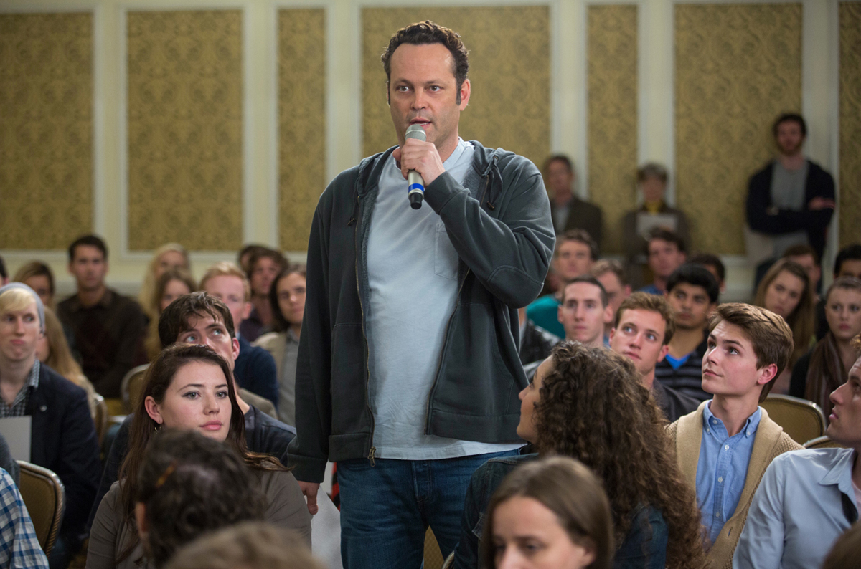
David is the eldest of three sons in the Wozniak family. He works for the family’s Brooklyn-based meat business with his father and brothers, but is a constant foul-up, albeit a loveable and likeable one. “David is a strange character,” explains producer André Rouleau. “Maybe he is not the best man in the world, but he’s got a big heart, and that’s why people love him.”
David’s past comes back to haunt him when he learns that the anonymous donations he made to a fertility clinic years ago under the pseudonym “Starbuck” have produced 533 Wozniak descendants, resulting in a paternity nightmare.
Adds Vaughn, “David is a guy who hasn’t grown up. He’s still very childlike in a lot of ways. He doesn’t have a lot of adult responsibility and he realizes that his girlfriend is pregnant. He owes money to some mobsters who are getting impatient and are giving him some pretty rough coaxing, and he’s constantly late on his bills.”
Writer/director Ken Scott was thrilled to give Vaughn the chance to tackle the role of David Wozniak. “It's always about how this impacts David's character,” Scott says. “So, for me, it was very important to find a great actor, someone good with comedy, someone who was strong enough to carry the whole movie on his shoulders, and someone who we would want to follow on this journey. Vince was very passionate about this story, he loved the story, he loved the character, obviously, and he has the talent to carry this movie. I felt he was perfect for this role.”
The filmmakers knew after just one meeting with Vaughn that they had found the right man. executive producer Scott Mednick recalls, “As we walked out to my car, the three of us looked at each other and said, ‘My God, he's David!’ Vince brings a depth and a heart to the role that I think audiences are not expecting … he does an amazing job. He takes this film on his back and delivers, for my nickel, the performance of his life.”
“He’s showing us another dimension of his major talent,” adds executive producer Mark Sourian. “Vince has always given great comedic performances. Now, with ‘Delivery Man,’ audiences get to see more of his versatility and depth as an actor. I think Vince was happy to play a part that was different from the roles he's had in the past. He definitely brings something amazing and unique to the character of David. I think, as a new father himself, he brought a personal understanding of the situation that nobody else could have performed as well.”

Delivering the Ideal Cast
“Delivery Man” brings together a unique ensemble of actors – comedy stars from both film and television, internationally acclaimed stars of stage and a host of talented newcomers – who together, create a dynamic and realistic chemistry.
Chris Pratt plays David’s best friend Brett, a fledgling lawyer raising four kids on his own. According to Pratt, “Brett is despondent, depressed, fat, at the end of his rope and buried in the responsibility of having four children. He's in a bad spot, and he sees the opportunity to represent David in this class action lawsuit as his last chance to reignite his passion.”
“Brett is one of David’s childhood friends,” says Vaughn. “I wouldn’t say that he’s a successful attorney, but he’s an attorney. He’s overwhelmed with being a father himself. He’s doing it on his own. And so, he’s telling David that he shouldn’t be a father, and particularly that David’s not equipped to be a father.”
“Chris Pratt was our first choice for the part,” says Sourian. “And, in fact, so much so, we more or less cast him without an audition or meeting. We felt he was the perfect confidant, for Vince.”
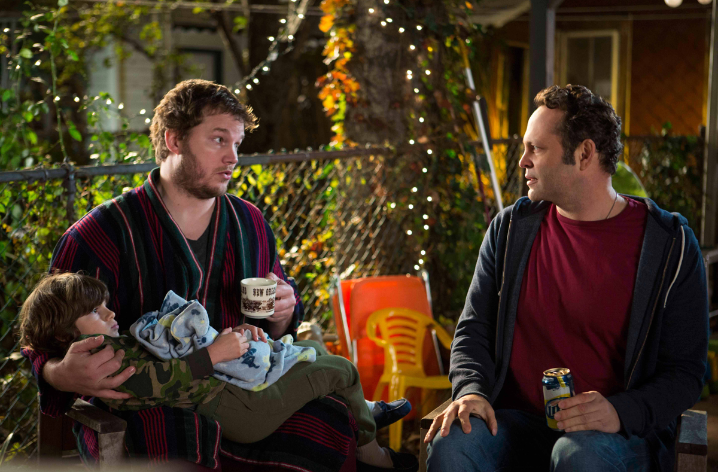
And sure enough, Vaughn and Pratt bonded on the set, quickly becoming each other’s biggest fan. “Chris is terrific,” says Vaughn. “He likes to have fun, he likes to joke around. He would make me laugh everyday on set, so it was easy jumping in and playing friends.”
Adds Sourian, “Brett mirrors the situation that David is in, in terms of finding themselves in an extraordinary situation that allows them both as underachievers to step it up and become the best versions of themselves. That's what makes the two of them so endearing. You want to root for them because they're underdogs, and that's part of the reason why you love them so much.”
For the role of David’s girlfriend Emma, the filmmakers were looking to cast an actress who could hold her own opposite Vaughn on both a dramatic as well as comedic level. The part went to Cobie Smulders, who exuded a unique combination of toughness and vulnerability.
“The story starts with a lot of conflict,” explains Scott. “This character is right away fighting with David, and we needed to feel that there was a connection, that even though they're fighting, we feel that these two are made for one another, they love one another, and they should be together. Cobie definitely brought that.”
He continues, “We also needed someone that could understand the comedy of the situation. She's in some very dramatic scenes, yet we needed these scenes to play out with a bit of levity, and Cobie definitely had that.”
In the film, Emma is all too familiar with David’s shortcomings and is desperate for him to grow up. The fact that she is pregnant with his child makes things all the more complicated.
Smulders explains, “David comes to her door very late at night, and he's trying to make up with her. He hasn't been in touch for a while, and Emma has been trying to get in touch with him because she's pregnant. She is a New York City police officer and she's battling with the idea of this man being her child's father. Will he support her? Is he a good father figure? And so it's a journey for both of them in a way that Emma learns to trust David and David grows up.”
As irritated as Emma is with David, part of her wants to give him the chance to step up to the plate. “David is flaky. He's one of those guys, who's so sweet, so charming, and everybody loves him,” observes Smulders. “But, he's not dependable. And for someone like Emma who is so by the book, who is much more organized, having this person in her life can be very frustrating.”
Smulders says, “When Emma reveals that she's pregnant to David, he goes on a quest to prove to her that he could be a good father. It's almost like he doesn't have to prove it to her first, but he has to prove it to himself first. He starts showing up for ultrasound appointments and becomes very supportive. In the end, upon revealing his identity to her and to the world, saying, ‘I'm the father, and I want to be there for these people,’ is a huge testament to him growing up, becoming responsible, becoming present, and it shows her what a good father he would be.”
While wanting to support Emma and be the father she’s hoping he could be, David is still conflicted about doing right by her and his biological offspring, as well as his father and brothers. “He has a lot of love and affection for Emma,” says Vaughn. “He realizes that his life and the way he conducts himself maybe doesn’t come off as the most consistent partner, but he wants to work on that because he does want to be a part of his child’s life, and he wants to be a part of Emma’s life.”
David's saving grace through all his mistakes and misfortunes is his family. “They’re a very close family,” says Vaughn. “Like most brothers, they tease each other, pick on each other and give each other a hard time, which makes you believe the relationship. But also, there’s a real deep bond there.”
Bobby Moynihan was cast in the role of Aleksy Wozniak, David’s protective younger brother, as the filmmakers knew he could convey the emotional nuances of a soon-to-be new father with a light-hearted but touching portrayal.
“I'm more of the sweet and nice one,” says Moynihan. “All of our scenes together are of me begging him not to screw up again, so I'm the nag of the family, but I am hoping that I'm keeping it all together, too.”
He continues, “At first, I'm telling him not to have children. I tell him it’s a gigantic mistake, because I'm about to have children. But then I have a child, and I realize how amazing and wonderful it is and I try to convey that to him.”
Moynihan shared a brotherly affinity with Vaughn off-screen as well. “It’s like he’s my big brother,” says Moynihan. “I don’t have a big brother, and the second I met him, it felt like he was my big brother already. He’s a very caring, nice person, so funny and just so amazing. He’s a great guy.”
Vaughn is equally complimentary of Moynihan. “Bobby does a great job,” says Vaughn. “He’s always funny on ‘Saturday Night Live’ and he is funny here as well, but he also has some more direct acting scenes which he does great in.”
Victor Wozniak, portrayed by Simon Delaney, is the tough talking, no nonsense one in the family. In playing opposite Delaney, Moynihan immediately discovered a kindred spirit. “The second I met him, I knew that I was going to know this guy for the rest of my life,” says Moynihan. “He’s the best. He’s a good guy.”
Acclaimed Polish actor Andrzej Blumenfeld is Mikolaj Wozniak, the warm and loving patriarch who believes that a father’s duty is to his family. Happiness for Mikolaj, is seeing his sons every day. According to Scott, “I wanted a very tight family to contrast with this very modern situation of a guy that has 533 kids. I wanted to have a very traditional family which is why I anchored this story into a Polish family that is very tight and still has a very traditional way of life as another way to explore what fatherhood is all about.
“Mikolaj is a very important character,” continues Scott. “We were looking for an actor who had a real Polish feel to him, and he had that very warm feeling of what I wanted this character to be. This was actually his first time ever in the United States, so he was very excited to come onto the project.”
When it came time to cast David’s biological kids, the filmmakers had one word they referred to consistently: Family. “We’re building a family,” says Scott. “I would put all the actors’ pictures up on a wall and see how they would look as a family. So, there was that interaction where I was not just picking this kid, I was building a family.”
He continues, “I had a picture of Vince up on the wall and then I said, ‘Okay, this could be one of his kids; then if this is one of his kids, maybe this could be. It was very interesting in the way that this family came together. Obviously, they needed to be credible as Vince’s kids, but on the other hand I wanted them to be very different.”
For Scott, discovering untapped talent was one of the highlights of making “Delivery Man.” “One of the great things is, we have all these kids that come in for a few scenes,” says Scott. “It was a great opportunity for me to go out, find these young actors, and work with them on set. It was very exciting to be putting all these young kids into the movie.”
Acting alongside a crop of young, eager, energized actors appealed to Vaughn as well. “The kids are great,” Vaughn says. “Always at that age, they come in excited. They’re very talented and committed, so it was just wonderful to watch. They all get a chance to do some great scenes. That isn’t common to see, but there are some powerful scenes in the movie.”
As David’s surreptitious encounters with the kids begin, he finds himself becoming immersed in their day-to-day lives. For Vaughn, the opportunity to delve into the lives of these characters was one of the most compelling aspects of the story. “What’s interesting is he gets the profiles of the children and becomes curious,” says Vaughn. “He can’t help but look into them. What’s fun about the movie, as a father myself, by actually playing it out with different kids from different backgrounds, I get to explore the thoughts that run through all parents’ minds, both the good things and the worries.
“David goes into all their lives at these early stages of becoming young adults,” continues Vaughn. “It’s very powerful because as a parent you think about those scenarios for your own life and your own kids, but to see someone play out so many different variations on that is very interesting.”
Jack Reynor plays Josh, an aspiring actor working as a barista in a neighborhood coffee shop. Reynor says, “Josh works behind a bar, somewhere in the city, and wants to be an actor but is stuck in this job that he doesn’t like very much. And so, David finds a way of helping him to achieve his goal, without actually telling him that he’s his father.”
Britt Robertson portrays Kristen, a young woman whose life has been filled with a number of setbacks and disappointments. “Kristen is a sweet soul who has a strong desire to be happy in her life but doesn't know how to go about doing it,” explains Robertson. “When David comes across her, she's going through a hard time. She just wants someone to love her, and that's what David does in a small way.”

She continues, “There's generosity with him. He’s so giving. She's never had someone come into her life and just care about her for no reason, but with the help and guidance of David, she goes on her journey in a way that's more successful than if she never had met him.”
Amos VanderPoel is Taylor, a lifeguard at the local YMCA. “He meets David after David shows up at the pool one day and tries to make some contact with him via the diving board.” VanderPoel says. “But he fails on a grand dive and I have to pull him out of the pool and resuscitate him and save him.”
VanderPoel was attracted to the film’s concept, finding it original and unconventional. “It’s got a nice mix of a lot of different things that people will like. Whether you're an adult or a kid, this is a movie that covers a lot of territory in terms of family dynamics, but also the goofy, fun side of things.”
Grocery store bag-boy Kyle is portrayed by Michael Oberholtzer, who almost passed on auditioning for the role. “I originally thought it was for a national Starbucks commercial,” recalls Oberholtzer. “But then I met the director and next thing you know I'm in the movie.”
Stephen Ellis portrays 18th Century Professor re-enactor. According to Ellis, “It's his first day on the job when David comes to see him. Robert is bad at it. He doesn’t know what he’s doing, and David inspires him over the course of his visits. Robert gets better and better at his calling.”
Street musician Adam is played by Dave Patten. “Adam’s a musician trying to make some coin, and get his music out there,” says Patten. “He’s real passionate about letting his emotions out, and letting it be heard by the world. David comes to the park where Adam is playing live and starts rocking out with him. It was weird for Adam to see this random guy be as enthusiastic as he was.”
For Patten, he sees “Delivery Man” as a crowd-pleasing comeback story. “It has so much heart,” he says. “You connect with Vince’s character and you want to see him make the right decision because he’s made so many wrong decisions throughout the film. You’re rooting for him and for the kids. And when he makes the right decision, it’s a great payoff for everyone.”
Jessica Williams is a spa technician who gives David his first professional pedicure. “She is an African-American spa worker who meets David at the nail salon that she works at,” says Williams. “He's reluctant at first, and then I end up giving him a very long foot massage along with a pedicure.”
Sébastien René plays Ryan, a child with special needs who is confined to a wheel chair. With apprehension and uncertainty, David visits Ryan, and at first, is tempted to run. But he is gradually won over, wanting to be there for him… as a friend and a father. The only returning actor from the original film, René’s emotionally stirring, masterful depiction of Ryan, again, provides an instrumental rite of passage for David.
Scott says, “Obviously, I was thrilled that we could bring him back, and he came back, and he did an awesome job, once again. In the original movie, the editor actually asked me if he was handicapped, or not. He's not; he's just a great actor. But, it shows you how great an actor he is, he never dropped it. He did a tremendous job.”
Adam Chanler-Berat is the goth and acerbic, Viggo, the only member of the 142 plaintiffs in the lawsuit to figure out David is actually Starbuck. The antithesis of David, Viggo is a social outcast who yearns to belong and be understood, yet demands to be independent.
“Viggo is a very serious kid who takes justice into his own hands, and lives his life in that way,” explains Chanler-Berat. “He becomes a leach to Vince's character in the movie. A loving leach.”
David is the key to unlocking the mystery of Viggo’s life. “Meeting David is everything that Viggo wants. He wants the truth, Viggo wants the real story about his life,” states Chanler-Berat. “He's been lied to for 17 years by his parents and that caused him a lot of suffering, and so he's on a quest, as a lot of people are in their late teens and twenties, to figure out who you are, where you came from, and what it means to be who you are on the planet. And so, that answer, that missing piece of the puzzle is important to Viggo in creating the larger image of his life, and his existence.”
It is the unanswered questions that keep all of David’s biological kids from feeling complete. “At the heart of what the kids in the movie are asking for, is not to have David become their adoptive parent,” observes Chanler-Berat. “What they're asking is for acknowledgement and truth in order for them to move on in their lives. At the end of the movie, David ends up granting the kids that very thing. He outs himself as the father and lets them into his life. And for these kids who have had a question mark, or a space in the place of a biological parent that means the world to them. That's the greatest gift that they probably receive.”

Bringing the Story To Life
“Delivery Man” is a re-telling of the 2011 French-Canadian comedy “Starbuck,” which was also directed by Ken Scott. With a title derived from a notorious breeding bull with a record-setting number of offspring, the film is about an unremarkable guy who wakes up one day to find he has fathered 533 children. Expanding on the original story with humor and heart, “Delivery Man” revisits this seemingly unlikely, but ultimately very possible tale of fatherhood and family.
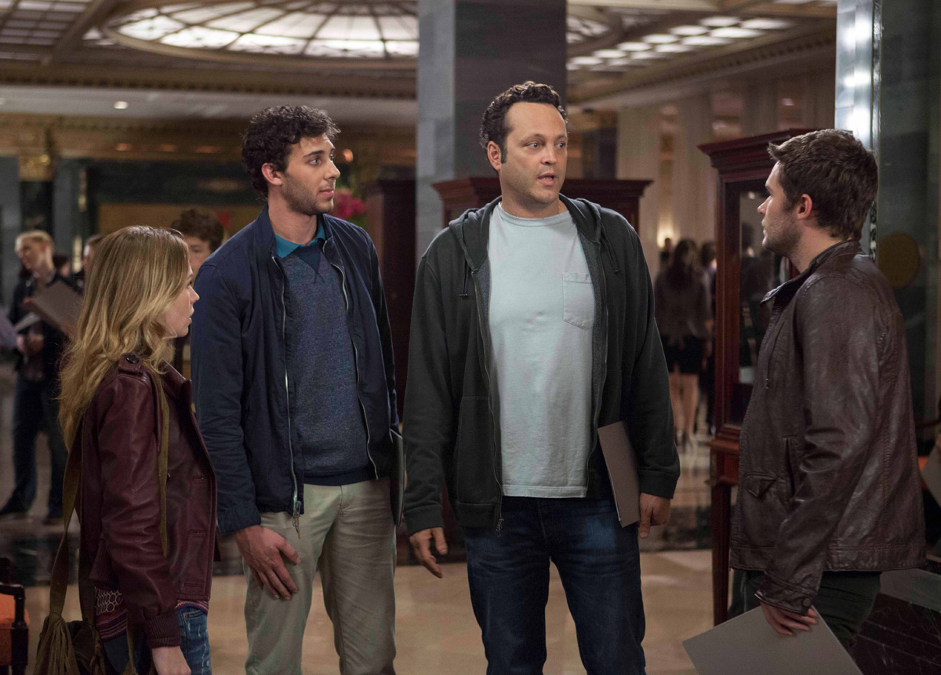
Scott recalls, “The idea came from my co-screenwriter, Martin Petit, who had this idea about a man who had many children. We wanted to write a comedy about fatherhood so we went for what we considered something extreme — a fertility donor who has 150 children. One month into the project, it was all over the media that a donor had discovered he had fathered 400 children! We were speechless and realized that our mere 150 was nothing compared to reality. So we actually had to bring up the numbers. We focused on creating a story that explores fatherhood in a playful and credible way.”
“Starbuck” premiered at the Toronto Film Festival, where it was selected as runner-up for the People’s Choice Award. The film went on to be named Most Popular Canadian Film at the 2011 Vancouver Film Festival and upon its theatrical release, became the most successful Quebec-made film that year.
The international popularity of “Starbuck” attracted the attention of many Hollywood producers who wanted to re-make the film for American audiences. According to Producer Rouleau, “Most of the offers we received were from people who wanted to produce a remake themselves. However, Ken and I wanted to reproduce the movie.”
Scott adds, “I wanted to be there as a director and as a writer to make sure that this delicate balance between drama, emotion and comedy wasn’t compromised. Not many filmmakers have the opportunity to redo the same movie a second time. But I love the story.”
Although “Delivery Man” is a remake, it was important to the filmmakers that the American version not be an identical regurgitation of the original. Scott says, “The goal of the remake is to basically take the story and to integrate it with American culture. For me, it was very important to make sure that we were not simply copying something. It had to come from a real place.”
It was Vaughn’s own family connection which first brought the project to his attention. His sister had seen the original film and loved it. And Vaughn immediately admired Ken Scott’s talent and enthusiasm for the project. “I think Ken’s incredible,” Vaughn states. “I’m just such a fan of his. He’s one of those guys who, interestingly, has all skills. He’s a phenomenal writer, and it’s nice to come to work every day and feel good with the script and have your job be just translating his lines.”
Vaughn continues, “He’s so smart with the camera, visually, and he’s also an actor, a performer. He knows how to talk to you and give you good ideas. He’s got a fun approach to stuff, and he’s a terrific filmmaker. He creates a fun atmosphere. He likes to joke around on the set, but he’s also very driven and knows what he wants.”
Chris Pratt is also a big fan. “He's a great guy,” Pratt says. “He told me something in rehearsal that I'll never forget. It was something about motivation in a scene that I'll use forever. It's about needs and desires. You take all of your character’s needs — for Brett, it was a need to lose weight, a need to reignite his passion, a need to get out of the house, a need for a break, a need for his kids to listen to him, a need to be respected and a need for his mother's respect. And then you find a desire that will fulfill all those needs. For Brett, it was this court case. So, that gives me all the motivation I need to navigate through the whole movie.”
He continues, “That's something nice, and maybe veteran actors all know that. But, it’s never been articulated to me that way, and I think for the rest of my life as long as I'm breaking down a scene, I'll use that. Not all directors can get you to think that way.”
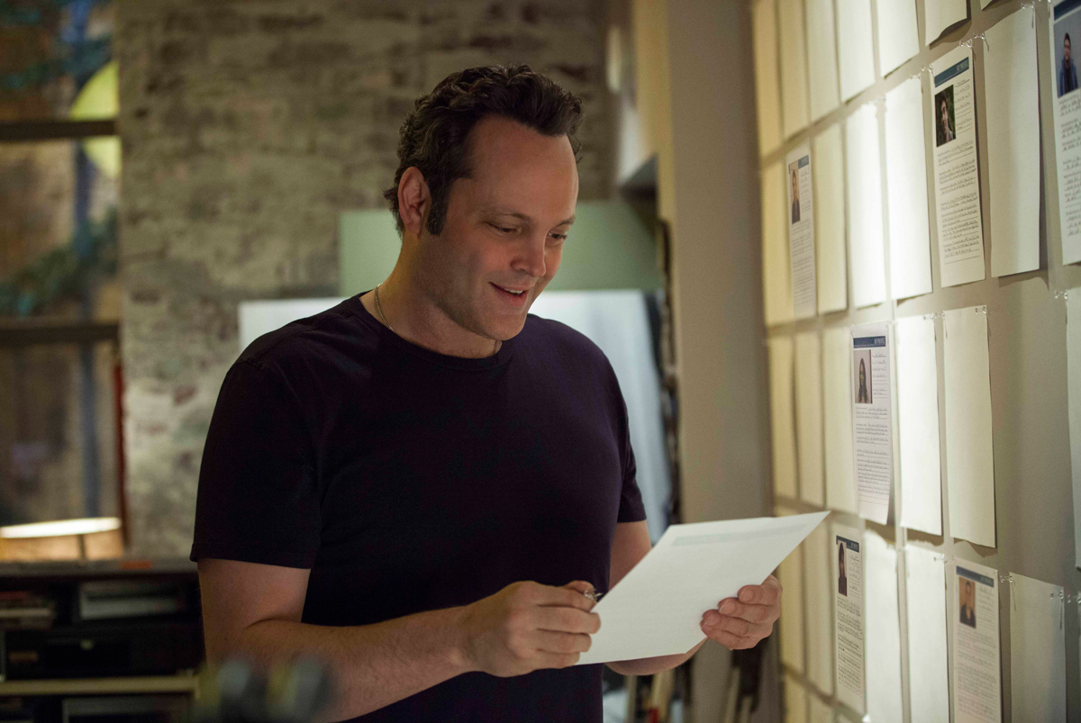
On its surface, “Delivery Man” is a comical look at a man facing an unimaginable quandary. But it is really a humanistic portrait of a man learning to accept his flaws and focus on turning his life around.
Executive Producer Mark Sourian says, “The thing that's so satisfying about the movie is we've found an extraordinary set of circumstances to put a character in the middle of. And yet those circumstances are very believable. There's a craziness to those circumstances that is comedic. You can't help but laugh.”
He continues, “But there’s also a seriousness to it, and I think that blend creates a very unique tone for the movie that allows it to be funny but emotional and heartwarming. That rich tone is what makes the movie feel very special and unique.”
David Wozniak represents the Everyman thrown into an extraordinary situation, who overcomes his circumstances to emerge a changed man. “He is a person who wants to be better. He just needs a push,” says Sourian. “It's hard not to root for somebody like that. He may not know how to do it, but you get a sense that he really wants to be better. I think that's something that all of us in one fashion or another can relate to.
From Pratt’s point of view, “Delivery Man” is an allegorical tale about family and fatherhood. “This is a movie that will actually make you think and feel something in your soul about family and fatherhood,” Pratt says. “You can't always do everything for everybody in your family. But you do what you can, and there's a reward in that. And that's what David Wozniak is doing – he's doing what he can.”
“It's the small things we do that make a difference, and that's what's so special about the movie,” says Sourian. “David is a very relatable character who certainly inspires in all of us, a sense that you can do great things without being some extraordinary person. It's an extraordinary situation, but he does very simple things that endear us to him because they make him better. And they make him the best person he can be.”

ABOUT THE CAST

VINCE VAUGHN (David Wozniak) is an actor, producer and screenwriter. He most recently starred opposite Owen Wilson in Fox Studios’ “The Internship,” a Shawn Levy-directed comedy that Vaughn wrote and produced as well. He is currently filming New Regency’s “The Business Trip,” with his “Delivery Man” director, Ken Scott. Last summer, Vaughn starred alongside Ben Stiller and Jonah Hill in “The Watch,” a comedy about suburban dads from a watch group that unveils a conspiracy to destroy Earth.
“Sullivan & Son,” an original sitcom, and the first venture from Vaughn’s Wild West Television Productions, premiered on TBS in July 2012 and was renewed for a second season. The show, produced by Vaughn, stars comedian Steve Bryne. The documentary, “Art of Conflict: The Murals of Northern Ireland,” which Vaughn produced and narrated, premiered at the 2012 Galway Film Festival in Ireland. He also co-starred with Kevin James in “The Dilemma,” directed by Ron Howard.
Vaughn co-wrote, and starred with Jon Favreau, Jason Bateman, Malin Akerman and Kristin Davis in Universal’s “Couples Retreat.” He also starred and produced the Warner Bros. hit comedy, “Four Christmases,” and starred alongside Sean Penn in the critically acclaimed “Into the Wild.”
In the summer of 2006, Vaughn created, produced, and starred in the hit anti-romantic comedy “The Break-Up,” co-starring Jennifer Aniston. This was the first feature film for Vaughn’s production company, Wild West Picture Show Productions. That same year, Vaughn released his first comedy documentary, “Vince Vaughn’s Wild West Comedy Show: 30 Days & 30 Nights – Hollywood to the Heartland.”
In 2005, Vaughn teamed with Owen Wilson in director David Dobkin’s hit comedy, “Wedding Crashers.” He worked again with director Dobkin starring in “Fred Claus,” a film he also co-produced. In addition, he starred alongside Luke Wilson and Will Ferrell in director Todd Phillips’ “Old School.” He re-teamed with director Phillips to star opposite Ben Stiller in the hit comedy “Dodgeball: A True Underdog Story.”
A Chicago native, Vaughn first caught the attention of critics and audiences in Doug Liman’s independent sleeper hit and cult classic “Swingers.” He reunited with “Swingers” screenwriter and co-star Jon Favreau in 2001 as producer and star of the comedy classic “Made.”
Among Vaughn’s many other film successes include “Be Cool,” “Mr. and Mrs. Smith,” “Thumbsucker,” “Domestic Disturbance,” “The Cell,” “Psycho,” “Clay Pigeons,” “Return To Paradise,” “A Cool Dry Place,” “Rudy,” “The Locusts” and “The Lost World: Jurassic Park 2.”

CHRIS PRATT (Brett) is most recognized for portraying Andy Dwyer on NBC’s hit comedy series "Parks and Recreation" opposite Amy Poehler, Nick Offerman, Aziz Ansari, and Rashida Jones. Emmy®-nominated “Parks and Recreation” is currently in production on its sixth season.
In 2011, Pratt starred in “Moneyball” where he delivered a memorable performance as Oakland A’s first baseman, Scott Hatteberg. The Columbia Pictures film also starred Brad Pitt, Jonah Hill and Philip Seymour Hoffman and received six Academy Award® nominations, including a nomination for Best Picture.
Pratt starred in the Universal feature “Five-Year Engagement” with Jason Segel, Emily Blunt, and Alison Brie in 2012. In the same year, he portrayed an iconic member of SEAL Team Six in Kathryn Bigelow’s “Zero Dark Thirty,” which was nominated for Best Picture for both the Golden Globes® and Academy Awards.
In February 2014, Pratt will be lending his voice to the Warner Bros. animated feature “The Lego Movie,” as the film’s lead character “Emmett.” Also lending their voices to the film are Will Ferrell, Liam Neeson, Morgan Freeman and Elizabeth Banks.
Pratt is currently in production on the Marvel feature “Guardians of the Galaxy,” where he plays “Star-Lord,” the leader of a group of alien superheroes sent out to defend the galaxy. Disney will release “Guardians” on August 1, 2014.
In addition to acting, Pratt includes among his other passions hunting, fishing and writing. He currently resides in Los Angeles with his wife and son.

COBIE SMULDERS (Emma) recently starred in “Marvel’s The Avengers,” which grossed over $1.5 billion worldwide, opposite Robert Downey Jr., Chris Hemsworth, Chris Evans, Mark Ruffalo, Jeremy Renner and Scarlett Johansson. In the film, she played S.H.I.E.L.D. Agent Maria Hill, the second-in-command operative, alongside Nick Fury (Samuel L. Jackson). She will reprise her role for “Captain America Winter Soldier” which will be released on April 4, 2014 and also for “The Avengers 2.”
She will next star in “David Wain’s “They Came Together” opposite Paul Rudd and Amy Poehler.
Her other film credits include: “Safe Haven,” “Grassroots,” “The Slammin’ Salmon” and “The Long Weekend.”
Smulders is also well known to audiences for her role as Robin Sherbatzky on CBS’s hit show “How I Met Your Mother.” The show has been nominated for an Emmy® for Outstanding Comedy Series, a People’s Choice Award for Favorite TV Comedy and a Teen Choice Award for Choice TV Show: Comedy. Her other TV credits include a starring role on the ABC drama “Veritas,” and the critically acclaimed Showtime series "The L Word."
On stage, Smulders performed in Nora Ephron and Delia Ephron’s off-Broadway hit, “Love, Loss, and What I Wore,” at the Westside Theatre. Directed by Karen Carpenter, the play was based on Ilene Beckerman’s 1995 book about clothes and the memories they trigger. Her other theatre credits include “Singin’ in the Rain,” “Grease” and “Women and Wallace.”
A Canada native, Smulders speaks fluent French.

ANDRZEJ BLUMENFELD (Mikolaj) was most recently seen as Teddy in “Faith Healer” (by Brian Friel) and in “The Graduate” (by Terry Johnson, adapted from the novel by Charles Webb) at the Dramatyczny Theatre in Warsaw, Poland. He has appeared in the adaptation of “Touch the Water, Touch the Wind” by Amos Oz, which was presented during the 10th Edition of the Jewish Culture Festival: Singer Warsaw. Blumenfeld appeared also in international productions including the 2005 TV movie “Pope John Paul II” by John Kent Harrison, and in 2002 movie “The Pianist” by Roman Polanski. From 1998 till 2013 he worked for the National Theatre in Warsaw and his credits include “Lorenzaccio,” “Much Ado About Nothing,” “King Richard III,” “Happy End,” “L'école des femmes” and “The Cherry Orchard.”
Blumenfeld was born in Zabrze (a city in Upper Silesia, southern Poland). In 1973 he graduated with a Master of Arts degree in acting from Aleksander Zelwerowicz State Theatre Academy in Warsaw.
In 1982 Blumenfeld moved to Berlin and worked there as an actor in Transformtheater which enabled him to act in German in “Castle” by Franz Kafka, “Ulysses” and “Finnegans Wake” by James Joyce. He is multilingual, fluent in English, German, Russian and to a lesser degree in French. In 1985 Blumenfeld returned to Poland where he worked in theater, television, movies and dubbing productions.

SIMON DELANEY (Victor) has been working as an actor and director for more than 16 years in Ireland and the UK, and more recently in the US.

Delaney is currently shooting his third series of “Moone Boy” directed and co-written by Chris O'Dowd. Prior to this he shot the “Alan Partridge Movie,” with Steve Coogan.

Other recent US screen credits include “The Good Wife” opposite Juliana Margulies and “Touch” which stars Kiefer Sutherland. Another recent feature film is “This Must be the Place” with Sean Penn. Simon played the title role in John Carney's feature film, “Zonad” which was nominated for 6 Irish Film & Television awards including Best Film, and was a huge hit at the Tribeca Film Festival, receiving a 5-star review from Variety magazine. Other European screen work includes “Moone Boy” (SKY TV), “Fathers & Son” (RTÉ/ITV) and “Roy” for CBBC, which received two BAFTA nominations. Simon has shot two TV series for BBC, “Pulling Moves” in which played the lead role, and “The Fall” with Gillian Anderson. Delaney has received 4 Irish Film and Television Academy Best Actor nominations, and for the past three years has hosted the ceremony, live on RTE television.

Theatre credits include “Stones in His Pockets” (Charlie Conlon) at The New Ambassadors & Duchess Theatres in London, “One Flew Over the Cuckoo’s Nest” (R.P McMurphy), “Glengarry Glenross” (Richard Roma), “The Odd Couple” (Oscar Madison), “The Boys in the Band” (Michael) and “Les Liaisons Dangereuses” (Le Vicomte de Valmonte). Delaney performed the Irish premier of “Defending the Caveman” at The Tivoli Theatre in 2007.

Musical theatre credits include “Jerry Springer the Musical” (Jerry), “The Blues Brothers” (Jake), “The Full Monty” (Dave), “42nd Street” (Julian Marsh), “The Wiremen” (Tommo), “Guys and Dolls” (Nathan Detroit) and “The Hired Man” (Isaac Tallentire).

Directing credits include “Beauty and the Beast,” “Stones in his Pockets” (German Premier & National Tour), “Cinderella,” “The Full Monty” (Irish Premier), “West Side Story,” “Sweet Charity,” “Honk,” “Oliver,” “Cabaret” and “The Hot Mikado.”

BOBBY MOYNIHAN (Aleksy) is a cast member on “Saturday Night Live” who has been with the show since 2008. He plays the crowd favorite, Drunk Uncle, on Weekend Update, along with other original characters such as Anthony Crispino, a second-hand news anchor who reports anything but the actual facts. Moynihan’s impressions include Nicole “Snooki” Polizzi, Guy Fieri, New Jersey Governor Chris Christie and Newt Gingrich.
Moynihan’s other television credits include memorable recent guest spots on HBO’s “Girls” and ABC’s “Happy Endings.” He’ll also be voicing the lead role in the upcoming animated comedy “Chozen” on FXX, produced by the creative teams behind HBO’s “Eastbound and Down” and the F/X animated series “Archer.”
On film, Moynihan had a supporting roe in the Adam Sandler comedy “Grown Ups 2” and voiced the character Chet in Disney•Pixar’s “Monsters University.” He will also appear in the upcoming films “Staten Island Summer” (produced by Lorne Michaels) and “Neighbors,” starring Seth Rogen and Zac Efron.
Moynihan’s past screen credits include “The Invention of Lying,” co-directed by and starring Ricky Gervais, “When in Rome,” with Kristen Bell and Josh Duhamel and “Mystery Team,” an indie from Derrick Comedy, which premiered at Sundance in 2009.
Moynihan is a fixture at the Upright Citizens Brigade Theatre in New York, where he continues to perform regularly at the signature weekly “Assssscat” show. He is also a co-founder of the sketch group Buffoons with friends Charlie Sanders and Eugene Cordero. The group’s antics, reminiscent of The Three Stooges, were a hit at Montreal’s Just for Laughs Comedy Festival in 2007.
Moynihan hails from Eastchester, New York and lives in New York City.
DAVE PATTEN (Adam) is a musician, writer, producer and actor.

This year, Patten published his first novel, “Run of The Mill,” a dramatic story about a rich playboy who must come to terms with his demons.

Patten’s career trajectory and creative drive can all be connected to his love of music. Growing up around everything from classical to R&B, Dave quickly took to the drums, mastering his skill-set with local bands. However, he didn’t stop there, conquering the piano, guitar, bass, trumpet, trombone and cello, which not only allowed him to hone his unique sound, but also to write and produce his own music. With a mix of acoustic, rock and synthesized melodies, his cross-genre style has garnered much attention. In 2006 Dave began posting videos on YouTube, amassing over 60 million page views and a social network following numbering in the thousands, and growing exponentially.

Patten grew up in Philadelphia, entrenching himself in the music scene there. As he made a name for himself in local venues, he continually strived to learn and grow as an artist. He continuously searches out unique and interesting projects that allow him any and all opportunities for creative outlet.

ADAM CHANLER-BERAT (Viggo) recently completed a successful run on Broadway as Peter in “Peter and the Starcatchers,” which garnered the most Tony® nominations by a new American play in the history of the Tony Awards. He also originated the role of Henry in the Pulitzer Prize-winning musical “Next to Normal” on Broadway and was with the show through its journey from the 2nd Stage & Arena productions. Additionally, Chanler-Berat recreated the role of Mark Cohen in the off-Broadway revival of “Rent.”
Last year, Chanler-Berat filmed the HBO pilot “The Corrections” with Ewan McGregor, Maggie Gyllenhaal, Chris Cooper, and directed by Noah Baumbach. He also appeared in an episode of CBS’ hit show “The Good Wife” and HBO’s “Veep.”

BRITT ROBERTSON (Kristen) is currently filming the lead role in Walt Disney Pictures’ feature film "Tomorrowland," opposite George Clooney. She starred this past summer on CBS's science fiction series "Under The Dome," based on Stephen King's novel of the same name. Last year she starred in the Castle Rock film "The First Time," opposite Dylan O'Brien, which premiered at Sundance.

Her other film credits include leading roles in the features "Undiscovered Girl," "White Rabbit" and "Dan in Real Life" opposite Steve Carrell. Robertson previously starred as a regular on the CW series' "The Secret Circle" and "Life Unexpected."

JACK REYNOR (Josh) is currently shooting “Transformers: Age Of Extinction,” the fourth installment of the “Transformers” series, in which he stars as Shane, along with Mark Wahlberg.
Last winter, Reynor garnered rave reviews for playing the titular character in the Irish independent film “What Richard Did.” Labeled as one of the best movies to come out of the Tribeca and Toronto Film Festivals, Reynor received glowing remarks from film critics around the globe.
Reynor was born in Colorado, but grew up in Ireland.

AMOS VANDERPOEL (Taylor) was born in Chicago and raised in Highland Park, IL. After conquering stage fright, he developed an interest in theater in high school. Soon after, he attended Syracuse University, graduating with a BFA in acting. This year, in addition to his role in “Delivery Man,” Amos was featured on an episode of “Deception.” He also composes and records music.

DERRICK ARTHUR (Jeffrey Smalls, aka Young Boozer) grew up in Grand Island, Nebraska. For the better part of 20 years, football and sports ruled his life. He first studied sports administration at the University of Nebraska-Kearney before finding his true calling as an actor while performing in a production of “Oklahoma!” at the university. He then auditioned for and was accepted into the New York Conservatory of Dramatic Arts where he graduated from their two-year Film & Television program.
Among his more prominent television commercial achievements is the “Bic® 4 Colour” Campaign. "Delivery Man" marks his feature film debut.

MICHAEL OBERHOLTZER (Bag Boy) has been seen on television in NBC's “Law & Order,” CBS's “NYC 22” and most recently, the FX hit show “The Americans.” His last film, “Hairbrained,” starring Brendan Fraser and Parker Posey, premiered at The Brooklyn Film Festival this past summer.
Oberholtzer has worked with many of the premier theatre companies in New York including: Second Stage, Classic Stage Company, New York Theatre Workshop, Joe Papp’s Public Theatre, The New Group, The Lark, Ensemble Studio Theatre and The Actors Company Theatre. He recently wrapped filming the new David Cross film entitled, “Hits” and was in the new Justin Timberlake music video, “Take Back The Night.” He is currently working on the new Showtime pilot, “Trending Down,” starring Phillip Seymour Hoffman and directed by John Cameron Mitchell.

STEPHEN ELLIS (18th Century Professor) made his New York theater debut at Lincoln Center in Nick Jones’ Obie Award-winning comedy “The Coward,” directed by Sam Gold. He subsequently appeared in Melissa Ross' “Thinner Than Water” with the critically acclaimed Labyrinth Theater Company.
Ellis will next be seen on screen starring as Touchstone in director Carlyle Stewart’s adaptation of “As You Like It,” scheduled for release in 2014. He has also appeared in many high profile commercial campaigns.
Ellis is a native of Texas, and a graduate from Kenyon College (where he won the Paul Newman Award for Acting) and The National Theater Institute.

MATTHEW DADDARIO (Channing) is a native New Yorker. He started acting as a teen but had little time for it, thanks to a busy schedule playing basketball in high school. After graduating from Indiana University with a degree in Business Economics, his interest in performing intensified and he decided to follow his passion.
He soon landed several independent features including writer Joey Dedio’s “36 Saints” and “Growing Up and Other Lies” directed by Darren Grodsky and Danny Jacobs. Ellis next appeared in Drake Doremus’s “Breathe In,” starring Guy Pierce and Felicity Jones which debuted at the 2013 Sundance Film Festival.
Outside of acting, Matthew is an amateur astronomer and also a member of the Wildlife Conservation Society.

ABOUT THE FILMMAKERS

KEN SCOTT (Writer/Director), after obtaining his certificate in screenwriting from I’Université du Québec à Montréal in 1991, started writing for the big screen. He first wrote a short film, “Hors la loi,” followed by his first feature, “La vie après l’amour,” that immediately won him recognition from his peers by receiving five nominations and awards at the 2001 Genie Awards.
In 2002, Scott wrote the sitcom, “Le Plateau,” in which he also played one of the lead roles. That same year, he wrote his second feature film entitled “La Grande Séduction” that closed the prestigious Quinzaine des réalisateurs at the Cannes Film Festival. The film directed by Jean-François Pouliot was praised and honored by critics in Quebec and around the world. It was shown in sixty-five international festivals and was sold in over 25 countries winning numerous important prizes such as the Public Prize Award at the Sundance Film Festival, the Grand Prize Jiraldillo d’oro and the ASECAN Prize at the Seville Festival, and the Bayar d’Or for Best Film at the Namur Festival and, last but not least, seven prizes at the 2004 Jutra Awards.
In recent years, he wrote the screenplay of the feature film “Maurice Richard,” directed by Charles Binamé, which received 14 nominations including Best Screenplay at the 2006 Jutra Awards. Scott’s screenplay was also nominated at the 2007 Genie Awards. That very same year, he went on to write his fourth feature film, “Le guide de la petite vengeance,” for which he was also nominated at a Genie Award.
In 2008, he wrote and directed for the first time the feature “Les doigts croches,” which was shot in Argentina and which won him another nomination for the Jutra prize for Best Screenplay.
He again acted as director and screenwriter on the feature film, “Starbuck,” starring Patrick Huard.

ANDRÉ ROULEAU (Producer), the president of Caramel Films, has been in the movie business since 1995. A lawyer by trade, he is one of the most prolific and successful Canadian film producers. At the 2011 Toronto International Film Festival, he received the Canadian Media Production Association’s Producers Award, which is given in recognition of the vision and entrepreneurship of an outstanding independent Canadian feature film producer.
Rouleau has produced many films met with critical acclaim and box office success, such as “Funkytown,” “Goon” and the original “Starbuck,” which is being remade in several countries including the USA (“Delivery Man”), where he produced it with DreamWorks. His most recent film, “The F Word” directed by Michael Dowse and starring Daniel Radcliffe and Zoe Kazan, premiered at TIFF where it garnered much critical acclaim. The film is being picked up for American distribution by CBS.
Rouleau is currently in postproduction on “Dr. Cabbie,” directed by Jean-François Pouliot, as well in production on “Ballerina,” an animation film coproduced with QUAD.
André Rouleau’s selected filmography includes “Head in the Clouds,” “An American Haunting,” the multi-genie award winning “Polytechnique,” “Die,” “Les Doigts Croches,” “L’instinct de Mort,” “Mesrine” and “Magasin des Suicides/The Suicide Shop.”

RAY ANGELIC (Executive Producer) is a Los Angeles-based producer whose credits include a host of critically acclaimed independent and genre films. Most recently he was an executive producer on Open Road’s Andrew Niccol film “The Host.” Prior to that Angelic was executive producer on “Fright Night,” starring Colin Farrell, Toni Collette and Anton Yelchin, and Charlie Kaufman’s “Synecdoche, New York,” starring Philip Seymour Hoffman, Dianne Wiest, Catherine Keener and Samantha Morton. The latter film screened in competition at the Cannes Film Festival, won two Independent Spirit Awards, received numerous critics’ awards and earned three nominations from the Visual Effects Society.
Previously, Angelic was a producer on the apocalyptic thriller “Carriers,” starring Chris Pine, Lou Pucci and Piper Perabo. This was just the latest of several collaborations with producer Anthony Bregman (“Eternal Sunshine of the Spotless Mind”).
Angelic’s executive producer credits include Guillermo Arriaga’s “The Burning Plain,” starring Charlize Theron, John Corbett and Jennifer Lawrence; “Friends with Money,” starring Jennifer Aniston, Catherine Keener and Frances McDormand, which received two Independent Spirit Award nominations; “The Wendell Baker Story,” directed by Luke and Andrew Wilson, starring Luke Wilson, Eva Mendez, Owen Wilson and Will Ferrell; “In the Cut,” directed by Jane Campion and starring Meg Ryan; “The Ex,” a romantic comedy directed by Jesse Peretz, starring Zach Braff, Amanda Peet and Charles Grodin; and “Once in a Life,” directed by and starring Laurence Fishburne.
Angelic’s first producing project was Bob Gosse’s “Julie Johnson,” starring Courtney Love and Lilli Taylor. The film, which premiered at the Sundance Film Festival, was produced in conjunction with the New York-based independent production company Shooting Gallery, where Angelic had a production deal at the time.

SCOTT MEDNICK (Executive Producer) has worked on more than 200 motion pictures in capacities ranging from marketing to on-screen graphics to producing and financing. The diverse films include “The Matrix,” “X-Men,” Walt Disney’s “Fantasia,” “A Few Good Men,” “Dirty Dancing” and “An American Werewolf in London.” In 2004 he was a co-founder of Legendary Pictures. Legendary's unique partnership brought together $500 million dollars from private equity and created a 25-picture deal with Warner Bros. to create an active production and finance entity. The initial deal included Legendary Pictures partnering with Warner Bros. to fund “Batman Begins” and the sequel “Batman: The Dark Night.”
Mednick has served on the producing team of such motion pictures as “Superman Returns,” “We Are Marshall,” “The Ant Bully,” “10,000 BC,” “300” and “Where the Wild Things Are.” Mednick helped usher in the new era of 3D motion pictures as part of the producing team behind “U2 3D” – the first live action 3D digital film ever made. Mednick has been a part of the financing and producing teams on motion pictures that have grossed more than $2 billion dollars at the box office. Mednick is currently producing the big summer remake of the famous “Teenage Mutant Ninja Turtles” franchise with Michael Bay for Paramount Pictures. He will produce the major motion picture adaptation of the worldwide phenomenon “American Gladiators.”
Mednick has left a mark on Hollywood as the creator of many of the corporate identity systems throughout the industry including the logos for Columbia Pictures, SONY Pictures, Legendary Pictures and Tri Star Pictures. In addition to his corporate responsibilities, he was a member of the National Board of Directors of the After-School All-Stars for 12 years. Under the leadership of its Chairman, Arnold Schwarzenegger, the ASAS has grown to 13 cities with participation of hundreds of thousands of children annually. Governor Schwarzenegger and the After-School All-Stars awarded Mednick their Inspiration Award at their 2007 star studded Gala in Beverly Hills. Under President Clinton, Mednick has served on the President's Committee for the Arts and Humanities task force for Children and Youth at Risk chaired by Hillary Rodham Clinton. He serves as a Trustee of the University of Santa Monica, on the Board of Communications Advisors to Children Now, and is on the Advisory Board of Education First. Mednick served on the International Board of Directors of Earth Day 1990 for which he also created the Logo and communications platform. He also is co-founder and a member of the Board of ECO (Earth Communication Office), which mobilizes the entertainment industry on behalf of the environment. He has been selected for inclusion in “Who's Who in the West” and “Who's Who in California.” He was also named Art Director of the Year by “Adweek” magazine.

MARK SOURIAN (Executive Producer) began his career as the assistant to Scott Rudin. He joined DreamWorks in 1997 as a development assistant and rose to the rank of co-president. He has shepherded projects such as the box office smash “The Ring” and its sequel “The Ring 2,” the Academy Award nominated film “House of Sand and Fog,” “Red Eye,” “The Kite Runner” and “Sweeney Todd: The Demon Barber of Fleet Street.” He was also the executive producer who oversaw the hit comedy, “I Love You, Man.”
Recently Sourian made the leap to producer, inking a first-look deal with DreamWorks, where he oversaw production on the upcoming drama, “Need For Speed,” starring Aaron Paul.

ERIC ALAN EDWARDS (Director of Photography) is an accomplished cinematographer whose mastery of visual composition spans across film, television and videos. He was nominated for an Independent Spirit Award and a Los Angeles Film Critics Association Award for Best Cinematography for Gus Van Sant’s, “My Own Private Idaho.”
On film, his impressive list of film credits include “Lovelace”; “The Change-Up”; “Stok Stalk Stock”; “Shelf Life”; “Virginia”; “Couples Retreat”; “Love Happens”; “Management”; “The King of Texas”; “Knocked Up”; “The Break-Up”; “First Snow”; “The Heart is Deceitful Above All Things”; “How to Deal”; “Crossroads”; “The Slaughter Rule”; “On the Edge”; “The Debtors”; “Clay Pigeons”; “Another Day in Paradise”; “Cop Land”; “Flirting with Disaster”; “Kids”; “To Die For”; “El jardin del Edén”; “Even Cowgirls Get the Blues”; “American Taboo”; “Last Night at the Alamo”; “Pay Dirt”; and “Property.”
His television endeavors include “Happy Valley,” “Inside Portlandia,” “Five,” and “Amy & Isabelle.”
Edward’s lens and lighting magic will appear in the upcoming “Untitled Elmore Leonard Project” starring Isla Fisher, Jennifer Aniston, and Tim Robbins.

IDA RANDOM (Production Designer) received an Academy Award® nomination for Best Art Direction Set Decoration for “Rain Man.” He has successfully ascended to one of the industry’s top-notch production designers, showcasing his imaginative and visual artistry in a multitude of films including “Chasing Mavericks”; “People Like Us”; “No Strings Attached”; “Charlie St. Cloud”; “Fast & Furious”; “Never Back Down”; “The Fast & the Furious: Tokyo Drift”; “Spanglish”; “Suspect Zero”; “A Man Apart”; “Along Came a Spider”; “The Postman”; “The Fan”; “Wyatt Earp”; “Hoffa”; “HouseSitter”; “Defending Your Life”; “The War of the Roses”; “How I Got Into College”; “Throw Momma from a Train”; “Who’s That Girl”; “About Last Night…”; “Silverado”; “Body Double”; “Irreconcilable Differences”; and “The Big Chill.”
Random’s other credits as production designer include made-for-television movies “Homeland Security,” “Homeward Bound,” and “Walt Disney’s Wonderful World of Color.”
PRISCILLA NEDD-FRIENDLY, A.C.E. (Editor) is a well-respected editor working behind-the-scenes on some of the silver screen’s most popular, and acclaimed motion pictures including “The Guilt Trip”; “The Darkest Hour”; “Big Mommas: Like Father, Like Son”; “The Back-Up Plan”; “The Proposal”; “27 Dresses”; “We Are Marshall”; “Big Momma’s House 2”; “The Haunted Mansion”; “Stuart Little 2”; “Down to Earth”; “American Pie”; “Rusty: A Dog’s Tale”; “Sour Grapes”; “The Evening Star”; “Clean Slate”; “Undercover Blues”; “That Night”; “Doc Hollywood”; “Guilty by Suspicion”; “Pretty Woman”; “Tucker: The Man and His Dreams”; “Street Smart”; “Lucas”; “The Flamingo Kid”; “No Small Affair”; and “Eddie and the Cruisers.”

MELISSA TOTH (Costume Designer) is a preeminent costume designer of film and television. A versatile costumer, she was nominated for a Costume Designers Guild Award for Excellence in Contemporary Film for “Eternal Sunshine of the Spotless Mind.”
She has created wardrobes for a multitude of films including “Margaret”; “Win Win”; “Henry’s Crime”; “The Rebound”; “Adventureland”; “Synecdoche, New York”; “The Visitor”; “No Reservations”; “Take the Lead”; “Prime”; “The Perfect Score”; “Nola”; “Hollywood Ending”; “Saving Silverman”; “Book of Shadows: Blair Witch 2”; “Maze”; “You Can Count on Me”; “Coming Soon”; “Luminous Motion”; “Too Tired to Die”; “Love God”; “The Deli”; “One Way Out”; and “Welcome to the Dollhouse.”
Toth’s costume creations have appeared on the small screen including the highly touted, Emmy® nominated HBO film “Too Big to Fail” directed by Curtis Hanson, starring William Hurt, Paul Giamatti, and Billy Cudrup.
“Academy Award®” and “Oscar®” are the registered trademarks and service marks of the Academy of Motion Picture Arts and Sciences.

JON BRION (Composer) has brought a singular musical voice to Paul Thomas Anderson’s films “Hard Eight,” “Magnolia” and “Punch-Drunk Love.” He has scored some of the past decade’s other unforgettably unorthodox films, such as Michel Gondry’s “Eternal Sunshine of the Spotless Mind,” Charlie Kaufman’s “Synecdoche, New York” and David O. Russell’s “I Heart Huckabees. He has also written music for the hit comedies “The Break-Up” and “Step Brothers,” and just recently completed the score for the gothic animated feature, “ParaNorman,” Judd Apatow’s “This is 40” and Pixar’s “Blue Umbrella” short.
Brion showed musical promise from his beginnings in New Jersey, and formed a band out of high school. He played with many artists including Aimee Mann and The Wallflowers before becoming a producer — and sometimes songwriter — for Fiona Apple, Rufus Wainwright, and Kanye West (among others).

# # #
As of 10.31.13

