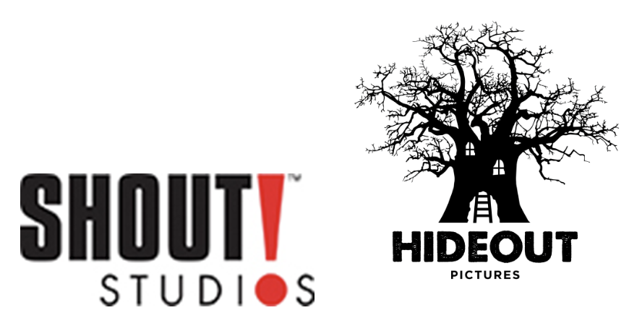
Shout! Studios Presents A Hideout Pictures Production

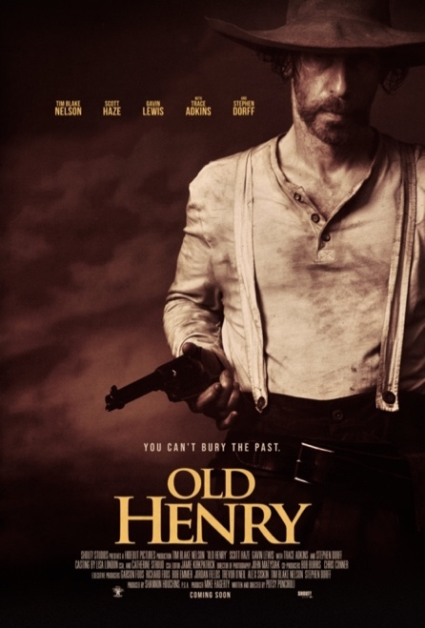

OLD HENRY
Written and Directed by Potsy Ponciroli

Starring Tim Blake Nelson,
Scott Haze, Gavin Lewis with Trace Adkins and Stephen Dorff

Press Notes

Running Time: 1 Hour 39 Minutes

Special Notes:
- In order to give movie audiences the opportunity to enjoy OLD HENRY to the fullest and allow them to discover any surprises and plot twists, we respectfully ask you to refrain from revealing spoilers and detailed story points in your coverage. Thank you!

Media Contacts:
Shout! Studios: Tom Chen and Lauren Blum, tchen@shoutfactory.com, lblum@shoutfactory.com
Falco Ink: Liza Connor, Emma Beidler, Janice Roland, Shannon Treusch, oldhenry@falcoink.com
Hideout Pictures: Claire Cook-Tayor, claire@averagejoesent.com

OLD HENRY
Shout! Studios Presents A Hideout Pictures Production

Genre: Action Western
Movie Run Time: 1 hour 39 minutes

Cast: Tim Blake Nelson (Henry), Scott Haze (Curry), Gavin Lewis (Wyatt),
Richard Speight Jr. (Dugan), Max Arciniega (Stilwell), Brad Carter (Branigan), with Trace Adkins (Al) and Stephen Dorff (Ketchum)

Written and Directed by Potsy Ponciroli

Produced by Shannon Houchins, p.g.a.

Producer Mike Hagerty, p.g.a

Executive Producers Alex Siskin, Garson Foos, Bob Emmer, Jordan Fields, Richard Foos,
Trevor O’Neil, Tim Blake Nelson

Co-Producers Bob Burris, Chris Conner

Director of Photography John Matysiak

Editor Jamie Kirkpatrick

Music Jordan Lehning

Casting by Lisa London, CSA and Catherine Stroud, CSA

SYNOPSIS

Old Henry is an action-Western about a widowed farmer and his son who warily take in a mysterious, injured man with a satchel of cash. When a posse of men claiming to be the law come for the money, the farmer must decide whom to trust. Defending against a siege of his homestead, he reveals a talent for gunslinging that surprises everyone, calling his true identity into question.

OLD HENRY

DIRECTOR’S STATEMENT

I’ve had a love of westerns since I was a kid. The lawlessness of the unsettled Wild West has been romanticized and fueled stories of iconic characters for generations. Stories of heroes and villains. Good vs. evil on the most basic level.

While scouting for another film I stumbled on this location in Watertown TN. This lonely house set back, sorta hidden from the world. The loneliness and solitude this location embodied, stuck with me. The story came from that. What would I do if a man showed up and swore he was a good guy who needed help only to have another man, right on his heels show up and swear he’s the good guy. How do you decide who to trust? How far would you go for a stranger in need? Now set that in the Western landscape where help isn’t a phone call away and it creates the tension and dire design of Old Henry.

It’s a “micro western” (a term I stole from Tim Blake Nelson), that pays homage to the great Westerns of the past. At its core, Old Henry is a story about a father and son. The struggles of a father trying his best to raise his son sheltered from the wrongs of his own past. Old Henry is also a story of redemption and forgiveness. It’s all of those things… and some badass gunfights.

- Potsy Ponciroli

OLD HENRY

ABOUT THE CAST

TIM BLAKE NELSON (Henry) and executive producer
Tim Blake Nelson is a prolific actor, writer, director, and producer who has appeared in a wide variety of films such as Lincoln, Holes, The Incredible Hulk, Meet the Fockers, Minority Report, and O Brother Where Art Thou? In 2018, Nelson starred as the title character in Netflix’s The Ballad of Buster Scruggs, written and directed by the Coen Brothers. In the film, Nelson performs “When a Cowboy Trades His Spurs for Wings,” which received an Oscar® nomination for Best Original Song. Nelson also won a Grammy Award for his performance of “In the Jailhouse Now” on the O Brother, Where Art Thou soundtrack album, which was awarded Album of the Year.

Most recently, Nelson starred in Just Mercy, The Report, Angel Has Fallen, and HBO’s Watchmen, based on the iconic graphic novel by Alan Moore. Nelson’s role in Watchmen as “Looking Glass” brought much acclaim and he was nominated for a Critic’s Choice award. In 2019, Nelson’s play Socrates premiered at The Public Theater in New York City. Other playwriting credits include The Grey Zone and Eye of God, both of which Nelson adapted and directed for the screen. Nelson will next be seen in Guillermo del Toro’s Nightmare Alley which Fox Searchlight will release in 2021.

SCOTT HAZE (Curry)
Scott Haze has been nominated for a SAG and Critic’s Choice ensemble award and for his performance in Minari. He just wrapped the lead male villain role in Jurassic World 3, having recently shot a flashy role in Scott Cooper’s film Antlers opposite Keri Russell, Jesse Plemons, and Graham Greene. He recently shot 12 Mighty Orphans and Vincent Grashaw’s indie What Josiah Saw, coming off Venom, Thank You For Your Service and Only the Brave.

The actor, writer, and director is best known for his breakout role in the 2014 film Child of God directed by James Franco and based on the novel by Cormac McCarthy, for which he was named one of Variety’s 10 Actors to Watch. Haze’s other film credits include Jeff Nichols’ Midnight Special opposite Michael Shannon and Joel Edgerton, Between Us opposite Olivia Thirlby, and multiple James Franco films such as The Institute, In Dubious Battle, The Sound and the Fury, As I Lay Dying, and Bukowski. His television credits include Robert Zemeckis’ Medal of Honor for Netflix.

GAVIN LEWIS (Wyatt)
Gavin Lewis stars in HBO Max’s upcoming reboot of the popular 1980’s sitcom Head of the Class, from Bill Lawrence and creators Amy Pocha & Seth Cohen. In film, Lewis co-stars opposite Tim Blake Nelson and Stephen Dorff in the upcoming action-western OLD HENRY, directed by Potsy Ponciroli. Lewis is known for his role starring alongside Reese Witherspoon (playing her son) and Kerry Washington in Hulu’s critically acclaimed drama series Little Fires Everywhere based on Celeste Ng’s best-selling novel of the same name. Prior to which, he starred in Netflix’s multi-camera comedy The Prince of Peoria portraying the lead title role of “Prince Emil.”
Lewis began his career on stage in his home state of Utah. The son of two theatre professionals, he was classically trained at a very young age, earning top honors at the Utah Shakespeare Festival's Acting Competition. Since moving to Los Angeles, he has appeared in a diverse range of television series, including Paramount Digital’s Maximum Ride, Syfy’s feature Omnious and NCIS: Los Angeles.
TRACE ADKINS (Al)

In his 25-year career in Country music, Trace Adkins has sold over 11 MILLION albums, charted over 20 singles, earned numerous awards and GRAMMY nominations, and garnered over TWO BILLION streams. A Grand Ole Opry member for nearly two decades, the Louisiana native is known for dynamic baritone and fiery, always-memorable live performances, and has expanded his Country career to include film and TV acting. He broke out in 1996 with the debut album, DREAMIN’ OUT LOUD, cracking the Top 5 of Billboard’s Hot Country Songs chart with “Every Light In the House Is On” and following with the #1 smash, “This Ain’t (No Thinkin’ Thing).” Since then, Adkins has pioneered a mix of classic Country minded traditionalism and adventurous, good-natured showmanship, breaking open new avenues in modern Country through fun-filled hits like “Honky Tonk Badonkadonk” and “Hillbilly Bone” (with Blake Shelton). He’ll celebrate the silver anniversary of his album debut in 2021 with THE WAY I WANNA GO, doing exactly what he always has – mixing pure-Country reverence with standout collaborations featuring Blake Shelton, Melissa Etheridge, Snoop Dogg, Stevie Wonder on harmonica and more. Adkins’ newest single “Where The Country Girls At” featuring Luke Bryan and Pitbull is available everywhere now and amassed over ONE MILLION streams within the first week of its release.

STEPHEN DORFF (Ketchum)

OLD HENRY
ABOUT THE FILMMAKERS

POTSY PONCIROLI, Director and Writer
Potsy Ponciroli, a 15-year veteran in film and television, he co-created and directed two-seasons of the half-hour scripted comedy series Still the King, starring Billy Ray Cyrus and Joey Lauren Adam. Ponciroli is also an executive producer on Jay and Silent Bob Reboot and Ted K, which premiered at the Berlin International Film Festival. He began his career directing music videos for Luke Bryan, Kenny Chesney, Yelawolf, Cage the Elephant and many others.

SHANNON HOUCHINS, Producer
Shannon Houchins is a Nashville-based producer whose projects include Jay & Silent Bob Reboot, and Ted K, as well as the soon-to-be- announced Plastic and Kill Whitey, adapted from the graphic novels of the same names. Television productions include the series Still the King, starring Billy Ray Cyrus and Joey Lauren Adams. Houchins is also a 30-year veteran of the music industry, currently servicing as CEO/ President of Nashville-based Average Joes Entertainment, whose roster of artists includes Colt Ford, Montgomery Gentry and others.

MICHAEL HAGERTY, Producer
Michael Hagerty has produced nine award-winning films, culminating this year with the western Old Henry, starring Tim Blake Nelson and Scott Haze. Hagerty’s movie producing credits include SGT. Will Gardner, starring Max Martini, Gary Sinise, Robert Patrick, and Dermot Mulroney, the teenage baseball drama Chance starring Matthew Modine, and Leave starring Rick Gomez, Frank John Hughes, and Bryan Cranston.

On the Television side, Hagerty developed and produced the Billy Ray Cyrus vehicle Still the King, which was sold to CMT and ran for two seasons. Last summer, A & E Studios bought the one-hour drama Steeltown from Hagerty. Jose Padiha is attached to direct the pilot. During a 20-year acting career, which included over 40 films and television shows, Hagerty produced and co-starred in The Last Big Attraction in 1999, which earned the Kodak Independent Vision Award.

JOHN MATYSIAK, Director of Photography
Cinematographer John Matyśiak has focused his career on shooting internationally recognized independent films that have been shown in 50 festivals around the world, including the Festival de Cannes. He recently began shooting Meet Cute, a genre-defying and stylish comedy starring Pete Davidson and Kaley Cuoco. Prior to shooting Old Henry, Matyśiak received the Best Cinematography award at the 25th Los Angeles Asian-Pacific Film Festival for his work on the feature films, Two Shadows and Model Minority. Matyśiak studied film at the Czech National Film School, FAMU, in Prague and at Emerson College in Boston, MA. He was raised in Houston, Texas.

HIDEOUT PICTURES
Hideout Pictures is a full-service content studio with offices in Nashville and Los Angeles. The company has created a fund designed to provide equity and gap financing to independent films, and to acquire IP to develop innovative content across a variety of platforms. The latest feature projects include Jay & Silent Bob Reboot, 3022, Ted K as well as the soon to be announced Plastic and Kill Whitey, adapted from the wildly successful graphic novels of the same name. Previous television productions include the single camera comedy Still The King starring Billy Ray Cyrus and Joey Lauren Adams. Currently Hideout is producing the feature film Old Henry starring Tim Blake Nelson and Music's Greatest Mysteries for AXS TV. Hideout also owns the newly launched distribution company Strikeback Studios.

SHOUT! STUDIOS
Shout! Studios is the entertainment production and distribution arm of Shout! Factory, specializing in all aspects of distribution, including theatrical, VOD, digital, and broadcast. Reflecting Shout! Factory’s ongoing commitment to innovation and excellence, Shout! Studios champions and supports like-minded filmmakers and creators at the forefront of pop culture, driving creative expression and diversity in independent storytelling. Shout! Studios finances, produces, acquires, and distributes an eclectic slate of movies, award-winning animated features, specialty films and series from rising and established talent, filmmakers, and producers.

